Junior Registration Form

Name (child)
Parent’s Name/Contact
Address
E-mail: |  | Phone(Home/Cell)
Date of birth (dd/mm/yyyy) |  | Gender (M/F)
Previous cricket experience (if any)

Registration fee is $80, due with this application, payable by Interac e-transfer to cricketnewfoundland@gmail.com, or cheque (mail to 78 Stirling Crescent, St. John’s A1A 4G9)

RELEASE
The applicant agrees that Cricket Newfoundland & Labrador and/or its proprietors will not be held responsible for any accidents or loss however caused, and agrees to release the proprietors from all claims or damages which may arise as a result of or by reason of such accidents or loss.

Pictures taken during sessions may be used for promotion purposes.

Signature:__________________________________ Fees Received: $________

Junior programme information
Dates : June 26 to August 31, 2019.
Ages : 8 to 14 years old, boys and girls are welcome
Location: Macdonald Drive soccer field (Fridays: 5:30pm – 6.45pm)
RCAF field, Torbay Road (Sundays: 6.00pm – 7.15pm)
- No equipment is required
- Participants should wear comfortable clothing for outdoors athletic exercise.
- A hat and sunscreen are however essential, particularly on bright days.

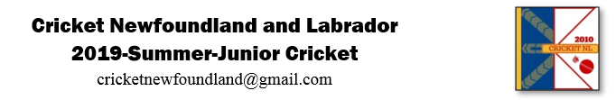
Invoice

Received $______ from ______________________________ towards the Summer Junior Cricket Programme fee for _____________________________.

_________________ ______________
For Cricket Newfoundland and Labrador Date

